**DA Assignment - 3**

**Objective:**

Students will create a detailed business performance report based on the data set, analyzing

sales, customer trends, and operational efficiency.

**Attribute information**

**Invoice id**: Computer-generated sales slip invoice identification number

**Branch:** Branch of super center (3 branches are available identified by A, B and C).

**City:** Location of super centers

**Customer type:** Type of customers, recorded by Members for customers using member

cards and Normal for those without member cards.

**Gender:** Gender type of customer

**Product line:** General item categorization groups - Electronic accessories, Fashion

accessories, Food and beverages, Health and beauty, Home and lifestyle, Sports and

travel

**Unit price**: The price of each product in $

**Quantity**: Number of products purchased by the customer

**Tax:** 5% tax fee for customers buying

**Total:** Total price including tax

**Date**: Date of purchase (Record available from January 2019 to March 2019)

**Time**: Purchase time (10 am to 9 pm)

**Payment:** Payment used by the customer for the purchase (3 methods are available –

Cash, Credit card and Ewallet)

**COGS:** Cost of goods sold

Gross margin percentage: Gross margin percentage

**Gross income:** Gross income

Rating: Customer stratification rating on their experience (scale of 1 to 10)

**Task:**

1. Import the Dataset: Load the provided dataset into Power BI.

2. Data Cleaning: Ensure data consistency and Create new Columns if required

3. Interactivity: Ensure the Report is interactive.

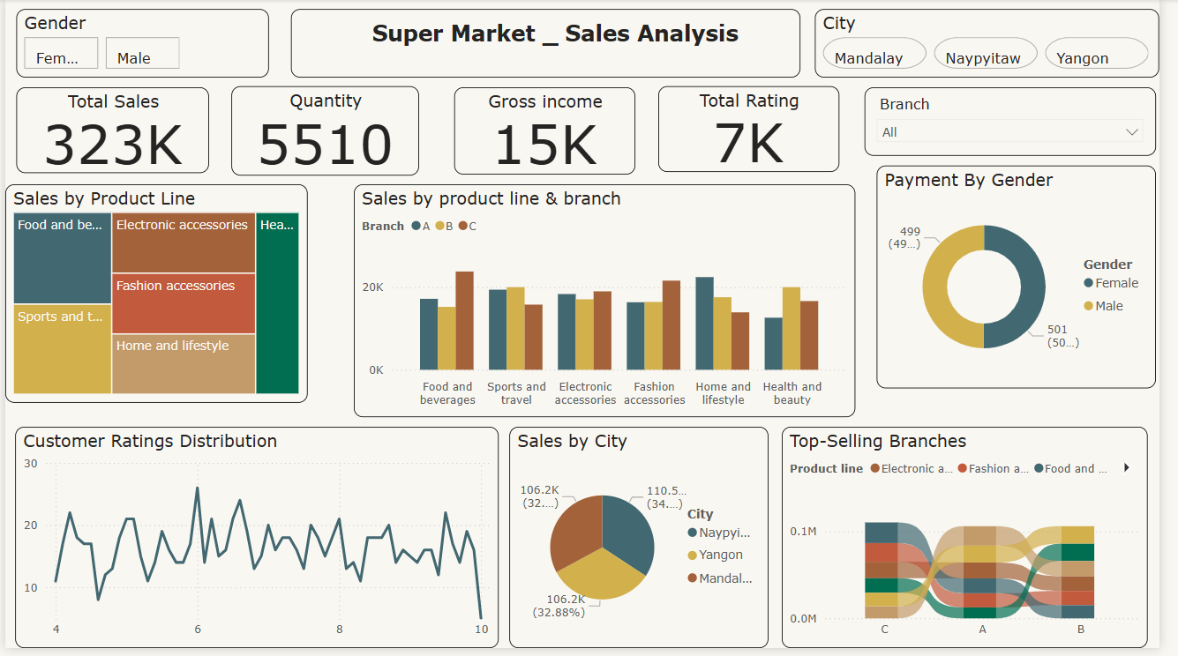

### ****Key Insights from the Dashboard****

**Sales Performance**: The **Total Sales** amount is **323K**, with a **Gross Income of 15K** and a **Total Quantity of 5510** units sold.

**Product Line Sales**: Food & Beverages, Electronic Accessories, and Fashion Accessories are the **top-selling product lines**.

**Sales by City**: Sales are almost evenly distributed among **Naypyitaw, Yangon, and Mandalay**, with each contributing roughly **33%** to total sales.

**Branch-Wise Performance**: Branches **A, B, and C** have varying performances across different product lines, with **Branch A leading in multiple categories**.

**Customer Ratings**: The **Customer Ratings Distribution** fluctuates between **4 and 10**, with some peaks around ratings of 6-7.

**Payment by Gender**: Sales are **almost evenly split between Male (50%) and Female (49%)**, indicating no significant gender preference in purchasing behavior.

**Slicers & Filters**: Users can **filter the data by Gender, City, and Branch**, allowing a dynamic exploration of sales trends.